Ideation Phase

Define the Problem Statements

|  |  |
| --- | --- |
| Date | 9 November 2022 |
| Team ID | PNT2022TMID52418 |
| Project Name | Project – AI-based localization and classification of skin disease with erythema |
| Maximum Marks | 2 Marks |

**Customer Problem Statement Template:**

Create a problem statement to understand your customer's point of view. The Customer Problem Statement template helps you focus on what matters to create experiences people will love.

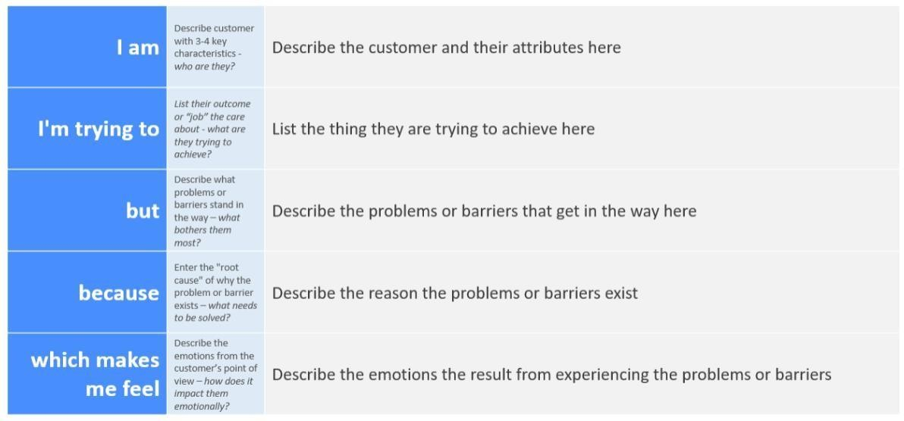A well-articulated customer problem statement allows you and your team to find the ideal solution for the challenges your customers face. Throughout the process, you’ll also be able to empathize with your customers, which helps you better understand how they perceive your product or service.

Reference: <https://miro.com/templates/customer-problem-statement/>**Example:**

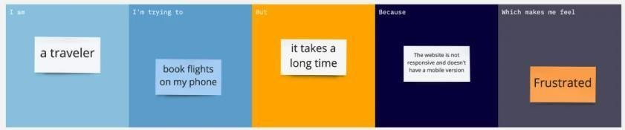

|  |  |  |  |  |  |
| --- | --- | --- | --- | --- | --- |
| **Problem Statement (PS)** | **I am (Customer)** | **I’m trying to** | **But** | **Because** | **Which makes me feel** |
| PS-1 | A man | can plant a tree | But the soil was so dry | He unable to too longer with that tree | He get frustrated |
| PS-2 | A man | can plant a tree | Now the soil condition is good  ,…but not the sunlight come there | He is plant a tree in behind the wall | He get frustrated |